Basic plot defaults
- The following should be pre-defined in the report_theme function
  - Panel background color is #F5F5F2 (light grayish white)
  - Plot background color is #FFFFFF (white)
  - Font style – Calibri
  - Font color - #000000 (black; for all displayed text)
  - Font size between 9pt – 12pt
- Maximum plot width – 6.5 inches (specified in ggasve function)
- Legend fill and color is # FFFFFF (white)
Below, are some colors that meet the minimum contrast ratio of 3:1 (for anything that isn’t text)
- #A6192E (MN purple red)
- #003865 (MN dark blue)
- #4D7493 (gray blue)

Tips and tricks for checking accessibility
- Use a color contrast analyzer tool
  - There is a Windows application called Colour Contrast Analyser (CCA) which is available through the Software Center
    - For most purposes, anything that fails in the AAA section (screenshot below) can be ignored

  - There is also an online tool called WebAIM (https://webaim.org/resources/contrastchecker/)
    - For most purposes, anything that fails in the highlighted sections (screenshots below) can be ignored
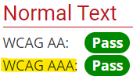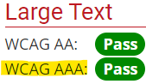
- Use the cvd_emulator function (from {colorspace} R package) to emulate different CVD types for an existing image file (ex. PNG).
  - Syntax
  - Generates the following file types (in current working directory):
    - desaturate_original file name
      - Image is converted to desaturated version (monochromatic vision or for black and white print out)
    - deutan_original file name
      - Image is converted to deuteranope vision (red-green color blindness)
    - protan_original file name
      - Image is converted to protanope vision (blindness to red)
    - tritan_original file name
      - Image is converted to tritanope vision (blue-yellow color blindness)
- Use cvdPlot function (from {colorBlindness} R package) to emulate different CVD types for a plot that exists in the R environment (first, you need to save the plot object to a variable name).
  - Syntax
- Use different shapes and line types to also differential between data points (not just color)
- Use different patterns with the R package {ggpattern} to add “texture” elements to plots like bar charts, histograms, and maps when the chosen color palette doesn’t meet the minimum color contrast ratio

Below is an example of using different colors, shapes, and line types in a single plot:
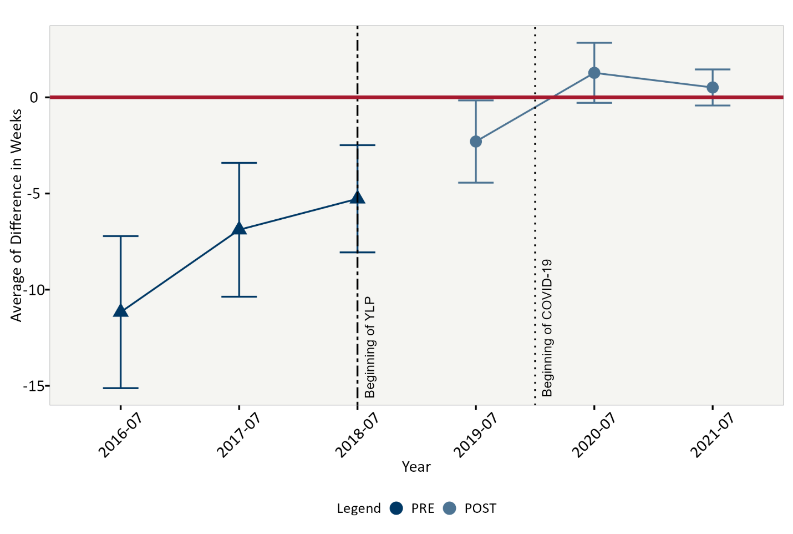
Example of using the {ggpattern} package
